# 没有注解哟

## Servlet

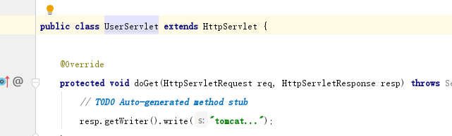

## filter

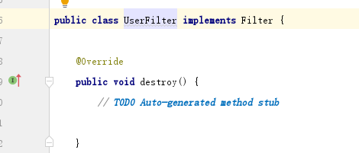

## Listener

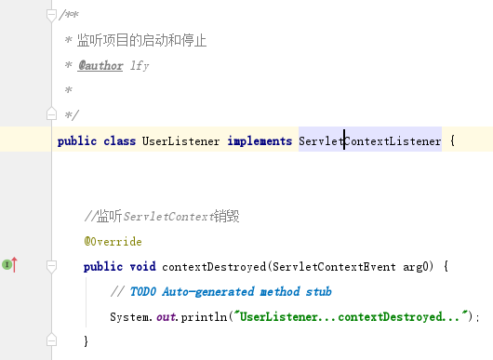

# ServletContext实现三大注解

## 概述

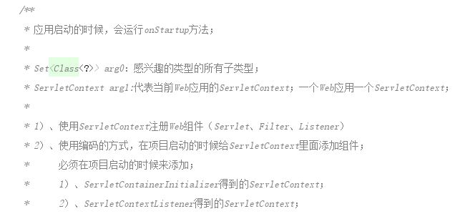

## ServletRegistration

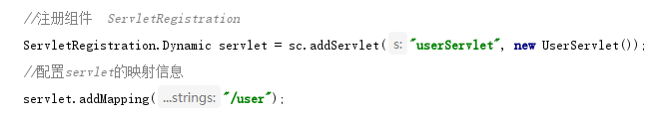

## FilterRegistration

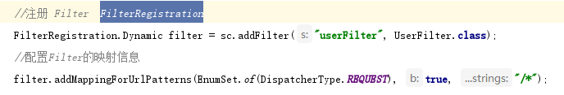

## Listener

